BANK LOAN REPORT QUERY DOCUMENT
- BANK LOAN REPORT | SUMMARY
KPI’S:
Total Loan Applications
SELECT COUNT(id) as Total_Loan_Applications FROM BanK_Loan_dataset
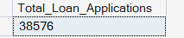
MTD Total Loan Applications (Month to Date: MTD)
SELECT COUNT(id) as MTD_Total_Loan_Applications FROM Bank_Loan_dataset
WHERE MONTH(issue_date) = 12 AND YEAR(issue_date) = 2021
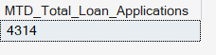
PMTD Total Loan Applications (Previous Month to Date: PMTD)
SELECT COUNT(id) as PMTD_Total_Loan_Applications FROM Bank_Loan_dataset
WHERE MONTH(issue_date) = 11 AND YEAR(issue_date) = 2021
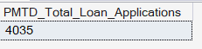
Total Funded Amount
SELECT SUM(loan_amount) as Total_Funded_Amount FROM BanK_Loan_dataset
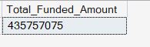
MTD Total Funded Amount
SELECT SUM(loan_amount) as MTD_Total_Funded_Amount FROM Bank_Loan_dataset
WHERE MONTH(issue_date) = 12 AND YEAR(issue_date) = 2021
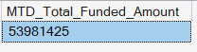

PMTD Total Funded Amount
SELECT SUM(loan_amount) as PMTD_Total_Funded_Amount FROM Bank_Loan_dataset
WHERE MONTH(issue_date) = 11 AND YEAR(issue_date) = 2021
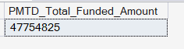
Total Amount Received
SELECT SUM(total_payment) as Total_Amount_received FROM Bank_Loan_dataset

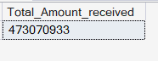

MTD Total Amount Received

SELECT SUM(total_payment) as MTD_Total_Amount_Received From Bank_Loan_dataset
WHERE MONTH(issue_date) = 12 AND YEAR(issue_date) = 2021

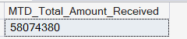

PMTD Total Amount Received
SELECT SUM(total_payment) as PMTD_Total_Amount_Received FROM Bank_Loan_dataset
WHERE MONTH(issue_date) = 11 AND YEAR(issue_date) = 2021

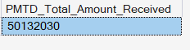

AVG Interest Rate
SELECT ROUND(AVG(int_rate),4) * 100 as AVG_Interest_Rate FROM Bank_Loan_dataset
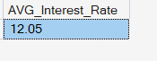
MTD AVG Interest Rate
SELECT ROUND(AVG(int_rate),4) * 100 as MTD_AVG_Interest_rate FROM Bank_Loan_dataset
WHERE MONTH(issue_date) = 12 AND YEAR(issue_date) = 2021
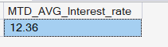
PMTD AVG Interest Rate
SELECT ROUND(AVG(int_rate),4) * 100 as PMTD_AVG_Intrest_Rate FROM Bank_Loan_dataset
WHERE MONTH(issue_date) = 11 AND YEAR(issue_date) =2021
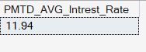
AVG DTI
SELECT ROUND(AVG(dti),4) * 100 as AVG_DTI FROM Bank_Loan_dataset

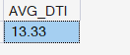

MTD AVG DTI
Select ROUND(AVG(dti),4) * 100 as MTD_AVG_DTI FROM Bank_Loan_dataset
WHERE MONTH(issue_date) = 12 AND YEAR(issue_date) = 2021
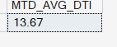
PMTD AVG DTI
Select ROUND(AVG(dti),4) * 100 as PMTD_AVG_DTI FROM Bank_Loan_dataset
WHERE MONTH(issue_date) = 11 AND YEAR(issue_date) = 2021
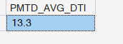

GOOD LOAN ISSUED
Good Loan Percentage
SELECT
(COUNT(CASE WHEN loan_status = 'Fully Paid' OR loan_status = 'Current' THEN id END)*100)
/
COUNT(id) as Good_loan_percentage
FROM Bank_Loan_dataset
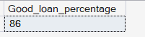
Good Loan Applications
SELECT COUNT(id) as Good_Loan_Applications FROM Bank_Loan_dataset
WHERE loan_status = 'Fully Paid' OR loan_status = 'Current'
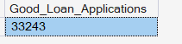
Good Loan Funded Amount
SELECT SUM(loan_amount) as Good_Loan_Funded_Amount FROM Bank_Loan_dataset
WHERE loan_status = 'Fully Paid' OR loan_status = 'Current'
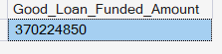
Good Loan Amount Received
SELECT SUM(total_payment) as Good_Loan_Amount_Received FROM Bank_Loan_dataset
WHERE loan_status = 'Fully Paid' OR loan_status = 'Current'
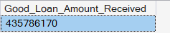

BAD LOAN ISSUED
Bad Loan Percentage
SELECT
(COUNT(CASE WHEN loan_status = 'Charged off' THEN id END) * 100.0)/
COUNT(id) as Bad_Loan_Percentage
FROM Bank_Loan_dataset
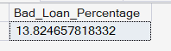
Bad Loan Application
SELECT COUNT(id) as Bad_Loan_Application FROM Bank_Loan_dataset
WHERE loan_status = 'Charged off'
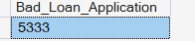
Bad Loan Funded Amount
SELECT SUM(loan_amount) as Bad_Loan_Funded_Amount FROM Bank_Loan_dataset
WHERE loan_status = 'Charged off'
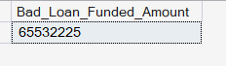
Bad Loan Amount Received
SELECT SUM(total_payment) as Bad_Loan_Amount_Received FROM Bank_Loan_dataset
WHERE loan_status = 'Charged off'
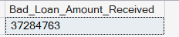

LOAN STATUS
SELECT loan_status,
COUNT(id) as Loan_Count,
SUM(total_payment) as Total_Amount_Received,
SUM(loan_amount) as Total_Funded_Amount,
AVG(int_rate * 100) as Interest_Rate,
AVG(dti * 100) as DIT
FROM Bank_Loan_dataset
GROUP BY loan_status
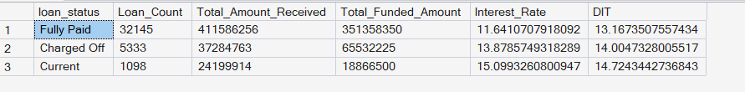
MTD Loan Status
SELECT
loan_status,
SUM(total_payment) as MTD_Total_Amount_Received,
SUM(loan_amount) as MTD_Total_Funded_Amount
FROM Bank_Loan_dataset
WHERE MONTH(issue_date) = 12
GROUP BY loan_status
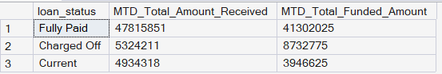

- BANK LOAN REPORT | OVERVIEW
MONTH
SELECT
MONTH(issue_date) as Month_Number,
DATENAME(MONTH, issue_date) as Month_Name,
COUNT(id) as Total_Loan_Applications,
SUM(loan_amount) as Total_Funded_Amount,
SUM(total_payment) as Total_Received_Amount
FROM Bank_Loan_dataset
GROUP BY MONTH(issue_date), DATENAME(MONTH, issue_date)
ORDER BY MONTH(issue_date)
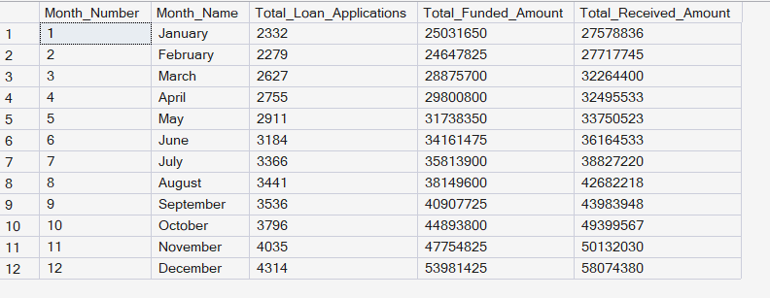

STATE
SELECT
address_state AS State,
COUNT(id) AS Total_Loan_Applications,
SUM(loan_amount) AS Total_Funded_Amount,
SUM(total_payment) AS Total_Amount_Received
FROM bank_loan_data
GROUP BY address_state
ORDER BY address_state
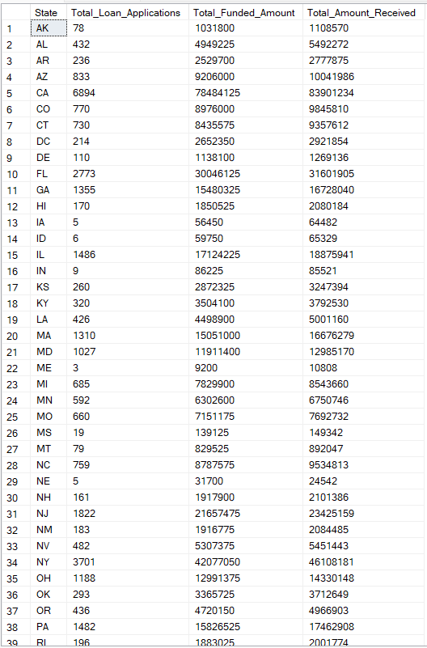
Loan Term
SELECT term,
COUNT(id) as Total_Loan_Applications,
SUM(loan_amount) as Total_Funded_Amount,
SUM(total_payment) as Total_Received_Amount
FROM Bank_Loan_dataset
GROUP BY term
ORDER BY term
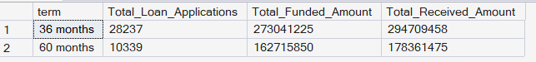
Employee Length
SELECT emp_length,
COUNT(id) as Total_Loan_Applications,
SUM(loan_amount) as Total_Funded_Amount,
SUM(total_payment) as Total_Received_Amount
FROM Bank_Loan_dataset
GROUP BY emp_length
ORDER BY emp_Length
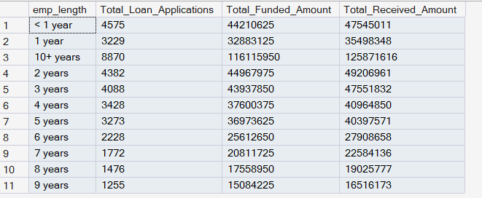
SAME BY DESC
SELECT emp_length,
COUNT(id) as Total_Loan_Applications,
SUM(loan_amount) as Total_Funded_Amount,
SUM(total_payment) as Total_Received_Amount
FROM Bank_Loan_dataset
GROUP BY emp_length
ORDER BY COUNT(id) DESC
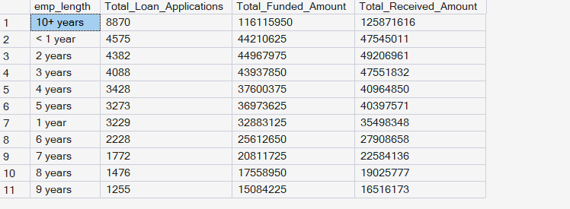
Loan purpose
SELECT purpose,
COUNT(id) as Total_Loan_Applications,
SUM(loan_amount) as Total_Funded_Amount,
SUM(total_payment) as Total_Received_Amount
FROM Bank_Loan_dataset
GROUP BY purpose
ORDER BY COUNT(id) DESC
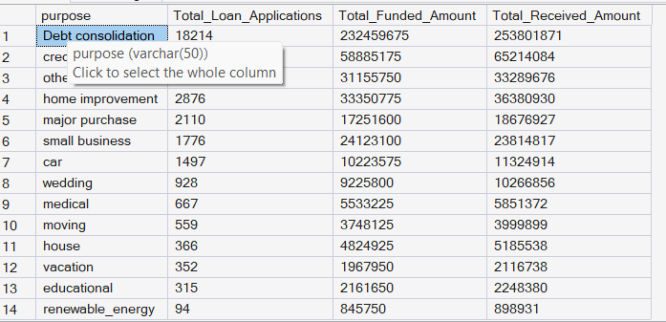

Home Ownership
SELECT home_ownership,
COUNT(id) as Total_Loan_Applications,
SUM(loan_amount) as Total_Funded_Amount,
SUM(total_payment) as Total_Received_Amount
FROM Bank_Loan_dataset
GROUP BY home_ownership
ORDER BY COUNT(id) DESC
